# **Team 7 - Communication Plan**

OPIM5270

Introduction to Project Management

**Project Champion:** Mark Tschiegg



**Project Members:**

Suraj Kumar

Luke LaRosa

Anita Sivakumar

Suriyaa Sugumar Valantina

Thejes Suprajagitanjali Venkataraman

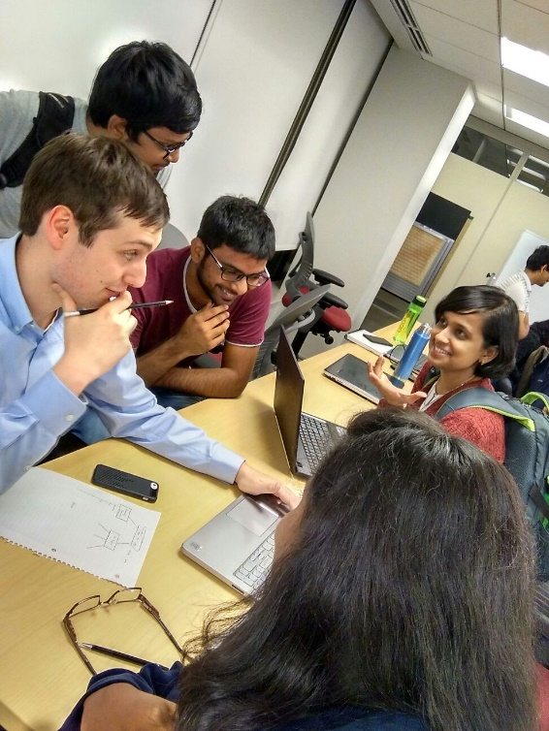

# **Contents**

|  |  |  |
| --- | --- | --- |
| S.no | Title | Page No. |
| I | Team Contact Information………………………………………………………… | 3 |
| II | Group Collaboration and Communication Mediums……………………………… | 3 |
| III | Group Meetings……………………………………………………………………. | 4 |
| IV | Group Decision-Making…………………………………………………………… | 5 |
| V | Conflict Management……………………………………………………………… | 5 |
| VI | Group Roles and Responsibilities…………………………………………………. | 6 |
| VII | Communication with Professor……………………………………………………. | 6 |
| VIII | RACI Matrix for Group Assignments……………………………………………... | 7 |
| XI | RACI Matrix for Granular Group Tasks…………………………………………… | 7 |

# **I: Team Contact Information**

|  |  |  |  |
| --- | --- | --- | --- |
| **Name** | **Phone Number** | **Email** | **General Availability** |
| Mark Tschiegg  (Project Champion) | (860) 486-1727 | mark.tschiegg@uconn.edu | Thursday 5:30 to 9 PM and All days through email |
| Suraj Kumar | (860) 997-5194 | suraj.kumar@uconn.edu | Thu & Fri - 5 to 6 PM |
| Luke LaRosa | (802) 272-1389 | luke.larosa@uconn.edu | Weekends,  Weekdays 4:30 – 6 PM |
| Anita Sivakumar | (313) 442-3704 | anita.sivakumar@uconn.edu | Weekends,  Tuesday  Other days – Before 12 noon |
| Suriyaa Sugumar Valantina | (860) 967-2044 | suriyaa.sugumar_valantina@uconn.edu | Sunday, Weekdays - Before 1.00 PM |
| Thejes Suprajagitanjali Venkataraman | (860) 328-6528 | thejes.sv@uconn.edu | Weekends, Weekdays - 9 AM-1 PM |

# **II: Group Communication and Collaboration Mediums**

1. ***Communication Medium***

|  |  |  |
| --- | --- | --- |
| ***Name of the medium*** | ***Purpose*** | ***Situations*** |
| ***WhatsApp*** | WhatsApp will be used for all informal group communication | Examples of informal communication include clarifying meeting time/dates, brief questions on the status of projects, brief clarifications on individual responsibilities, and alerts if individuals are unable to attend meetings. |
| ***Email*** | Email will be used for any formal communications or for communication in which documents/presentations/worksheets that cannot be formatted correctly in Google Docs need to be shared with group members | Examples include sending formatted copies of assignment drafts of final drafts for comments or to confirm approval before submission. |
| ***Telephone*** | Telephone conversation will be used for time-sensitive issues | Examples include receiving confirmation for submitting assignments, rescheduling meetings at last minute, etc. |

1. ***Collaboration Medium***

|  |  |
| --- | --- |
| ***Name of the medium*** | ***Purpose*** |
| ***Google Docs*** | Google Docs will be used for brainstorming and drafting assignments so that all group members can contribute to and check in on assignments as they are being developed and completed. Submissions will require reformatting the Google Docs content and modifying in a Microsoft Office compatible format (i.e., Word, PowerPoint, Excel). Individuals in the “Responsible” role category for each assignment will be responsible for converting Google Docs content. |
| ***Google Drive*** | Google Drive will be used to store all deliverables, meeting agendas and meeting notes in a structured format accessible to all group members. |

# **III: Group Meetings**

*Standing Meetings*

The group will have a standing weekly meeting from 5pm to 6pm on Thursdays prior to class. We will meet in the GBLC outside of classroom 407.

***If a team member is unable to attend the standing meeting, they will alert other members through WhatsApp and send other group members any materials needed to work on or complete assignments.***

*Additional Group Meetings*

On an as-needed basis, the group (or a subset of the group depending on the assignment) will meet outside of the usual standing meeting time. These meetings will be scheduled as necessary through WhatsApp, and all members will be alerted of additional working meetings.

It is understood that not all members may be able to attend additional meetings in-person. When an individual cannot attend a weekend meeting in-person, other group members will Skype or conference call so that all members have the ability to participate in group work.

*Meeting Protocol*

**Meeting Agendas:** Meeting agendas will be kept in a Google Drive location accessible to all group members. The agendas will have a sample template of weekly items (i.e., check in on assignment status), but any group member can add recommended items to the weekly agenda stored in the group’s Google Drive.

**Meeting Facilitator:** Responsibility for facilitating meetings will rotate among group members. At the end of each standing meeting, a group member will elect to facilitate the next meeting. The facilitator will be responsible for checking in and arranging the agenda and for ensuring the standing meeting runs smoothly. For supplemental meetings, members can volunteer to facilitate as needed.

**Meeting Minutes:** Responsibility for taking meeting minutes will rotate among group members. At the beginning of each standing meeting, the group will select who will take minutes. The group member assigned to take minutes for the week will need to ensure all minutes are recorded in the group’s minutes document within the Google Drive. For supplemental meetings, a group member will volunteer to record minutes and also post to the group’s Google Drive.

# **IV: Conflict Management**

*MSBAPM Team Norms*

At all times, every member of the group will abide by the MSBAPM Team Norms in order to avoid conflict. While the MSBAPM Norms can be found in the class HuskyCT page, primary examples include:

* Treat each other with dignity and respect
* Do not be defensive towards colleagues
* Support each other
* If you commit to something, do it—be accountable and responsible
* Attend and be prepared for team meetings
* Confront each other with care, compassion, and purpose if a team member is struggling to meet the Team Norms

Note: The above is a sample list of Norms. The group will commit to reviewing the full list on HuskyCT.

*Handling Conflict*

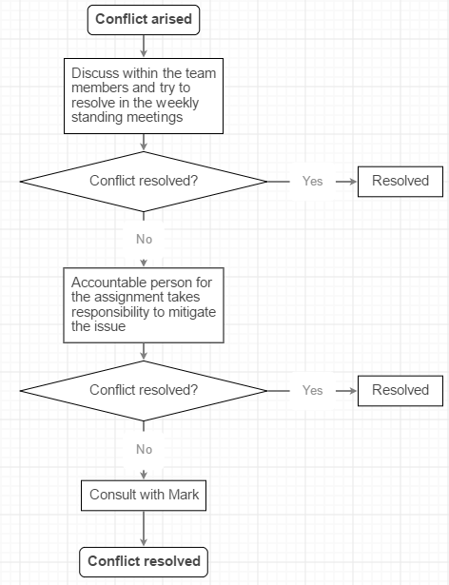

That said, group members will do whatever possible to adhere to the MSBAPM Norms and resolve conflict in order to prevent escalation.

# **V: Group Decision-Making**

Group decisions will, whenever possible, be made by consensus. For instance, group decisions to alter the communication plan or RACI matrix will require group conversation and approval. In terms of individual assignments, the decision to submit the current draft of an assignment will need to be approved by all individuals that are in the “Accountable,” “Responsible,” or “Consult” level of the RACI matrix for the given project.

*Group Contingency Plans*

The group member that is in the “Accountable” role for an assignment will ultimately be responsible for determining how to move forward as a contingency. In the event that an assignment is running behind or does not meet the requirements, the “Accountable” individual will determine how to proceed (i.e., if the assignment needs to be submitted without approval of “Consult” individuals or if additional members may need to step in to assist with an assignment that is not on-track).

If the “accountable” individual is failing to do the above, then the responsible individual(s) will be responsible for determining the best course of action.

# **VI: Groups Roles and Responsibilities**

The group will use the RACI framework to organize roles and responsibilities for each of the various team assignments (see the following RACI matrices for projects and other group tasks). The following outlines what each role will be responsible for:

**Responsible -** Individuals that are responsible for an assignment will do the work required in Google Docs where possible and then convert the information to a Microsoft format. Responsible individuals will, whenever possible, have the assignment completed more than 24 hours before it is due and inform the accountable member when the assignment is completed. “Responsible” individuals will submit the assignment to the individual that is “Responsible” for communicating with Mark (see Section 7).

**Accountable -** The “Accountable” individual will be responsible for ensuring that work is being completed and then submitted the work to HuskyCT once the assignment is complete. The accountable member will only do so after confirming that all of those listed as “Consult” have had a chance to review submission. When necessary, the “Accountable” member will make final edits.

**Consult -** Individuals listed as consult will have the ability to provide input throughout the assignment and then the ability to confirm that the assignment is complete prior to submission.

**Inform -** Individuals listed as inform will be able to see the document during development in Google Docs and will be informed when the assignment is complete.

# **VII: Communication with Mark**

Communication with Mark on behalf of the group will happen through email by the “Responsible” individual for that task (see section VIII). Any clarifications on assignments after reading all materials will be done by meeting with Mark in person after class. If Mark is not available, we will contact Alekhya.

# **VIII: RACI Matrix for Group Assignments**

The following outlines the RACI matrix the group will use to organize roles and responsibilities throughout the semester to ensure work is completed.

|  |  |  |  |  |  |  |  |
| --- | --- | --- | --- | --- | --- | --- | --- |
| Assignment | Due Date | Suraj | Luke | Anita | Suriyaa | Thejes | Mark* |
| Communication Plan | 9/22 | C | A | R | R | C | I |
| Charter | 9/29 | C | R | R | A | R | I |
| Revised Charter | 10/6 |  | R | R |  | A | I |
| Gantt Chart/WBS | 10/13 | R |  | A | C | R | I |
| Project Update #1 | 10/20 | A | R |  | R |  | I |
| Project Update #2 | 10/27 | R | R | A |  |  | I |
| Project Update #3 | 11/3 |  | R |  | A | R | I |
| Project Update #4 | 11/10 |  |  | R | R | A | I |
| Final Presentation | 11/27 | R | A | R | R | R | I |

The RACI matrix may change over the course of the semester. If an adjustment is necessary, the group member requesting the change will confirm with the rest of the group during our standing meeting.

*Project Champion will be informed through our submissions.

# **IX: RACI Matrix for Granular Group Tasks**

|  |  |  |  |  |  |
| --- | --- | --- | --- | --- | --- |
| **Name of the Tasks** | **Suraj** | **Luke** | **Anita** | **Suriyaa** | **Thejes** |
| Communicating with Mark |  | R |  | A |  |
| Substitute for communicating with Mark |  |  | R | A |  |
| Creating drive location for deliverables | A |  | R |  |  |
| Maintaining repository of deliverables |  |  |  | R | A |
| Preparing Agenda | R |  |  |  | A |
| Ensure to assign a meeting facilitator |  | R | A |  |  |
| Ensure to assign note taker for minutes |  | A |  |  | R |
| Plan post-presentation celebration | R | A |  |  |  |